**LAB # 5**



**CSE-203L Circuit & Systems-II Lab**

**Fall 2022**

**Submitted by: Ali Asghar**

**Registration No.: 21PWCSE2059**

**Class Section: C**

“On my honor, as student of University of Engineering and Technology, I have neither given nor received unauthorized assistance on this academic work.”

Student Signature: ______________

Submitted to:

**Engr. Faiz Ullah**

15th November, 2022

Department of Computer Systems Engineering

University of Engineering and Technology, Peshawar

**TITLE:**

**Parallel R, L, C Circuits**

**OBJECTIVES:**

* To examine the voltage and current relationship in parallel R, L, C networks.
* To study how Kirchhoff’s current law is extended for AC circuits.
* To know about domains and phasor plots of the current.
* To learn technique to measure current using current sense resistors.

**APPARATUS:**

* Oscilloscope
* AC Function Generator

**COMPONENTS:**

* 1 nF Capacitor
* 10 mH Inductor
* 1k Ω Resistor

**THEORY OVERVIEW:**

Each element has a unique phase response: for resistors, the voltage is always in phase with the current, for capacitors the voltage always lags the current by 90 degrees, and for inductors the voltage always leads the current by 90 degrees. Consequently, a series combination of R, L, and C components will yield a complex impedance with a phase angle between +90 and -90 degrees. Due to the phase response, Kirchhoff’s Voltage Law must be computed using vector (phasor) sums rather than simply relying on the magnitudes. Indeed, all computations of this nature, such as a voltage divider, must be computed using vectors.

**RLC PARALLEL CIRCUIT:**

An RLC Parallel circuit is an [electrical circuit](https://en.wikipedia.org/wiki/Electrical_circuit) consisting of a [resistor](https://en.wikipedia.org/wiki/Electrical_resistance) (R), an [inductor](https://en.wikipedia.org/wiki/Inductor) (L), and a [capacitor](https://en.wikipedia.org/wiki/Capacitor) (C), connected in parallel. The name of the circuit is derived from the letters that are used to denote the constituent components of this circuit, where the sequence of the components may vary from RLC.

**RLC SERIES CIRCUIT DIAGRAM:**

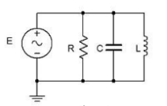

Figure 1

**PROCEDURE:**

1. Using Figure 1 with a 10 V p-p 10 kHz source, R=1kΩ, C=10nF and L=10mH, determine the theoretical capacitive reactance, inductive reactance and circuit impedance, and record the results in Table 1 (the experimental portion of this table will be filled out in step 5). Using the current divider rule, compute the currents in resistor(iR), inductor(iL) and capacitor(iC) and record them in Table 2.
2. Build the circuit of Figure 1 using R=1kΩ, L=10mH and C=10nF. A common method to measure current using the oscilloscope is to place a small current sense resistor in line with the current of interest. If the resistor is much smaller than the surrounding reactance it will have a minimal effect on the current. Because the voltage and current of the resistor are always in phase with each other, the relative phase of the current in question must be the same as that of the sensing resistor’s voltage. Each of the three circuit currents will be measured separately and with respect to the source in order to determine relative phase. To measure the total current, place a 10Ω resistor between ground and the bottom connection of the parallel components. Set the generator to a 10 V p-p sine wave at 10 kHz.
3. Place probe1 across the generator and probe2 across the sense resistor. Measure the voltage across the sense resistor; calculate the corresponding total current via Ohm’s Law and record in Table 2. Along with the magnitude, be sure to record the time deviation between the sense waveform and the input signal (from which the phase may be determined eventually).
4. Remove the sense resistor and place one 10Ω resistor between the capacitor and ground to serve as the capacitor current sense. Place a second 10Ω resistor between the resistor and ground to sense the resistor current, and a third 10Ω resistor between the inductor and ground for the inductor current. Leave probe one at the generator and move probe two across the sense resistor in the resistor branch. Repeat the process to obtain its current, recording the magnitude and phase angle in Table 2. I a similar way move probe2 so that it is first across the capacitor’s sense resistor and then across the inductor sense resistor. Measure and record the appropriate values in Table 2.
5. Compute the deviations between the theoretical and experimental values of Table 2 and record the results in the final columns of Table 2. Based on the experimental values, determine the experimental Z, XL and XC values via Ohm’s Law (XC =VC/IC, XL=VL/IL and XZ=Vin/iin) and record back in Table 1 along with the deviations.
6. Create a phasor plot showing iin, iC, iL and iR. Include both the time domain display and the phasor plot with the technical report.
7. Repeat the experiment for any values of C, L and R.

**OBSERVATIONS:**

For V(p-p) = 2V, f = 10KHz, R = 1kΩ,L = 10mH, and C = 10 nF

**CIRCUIT DESIGN IN PROTEUS:**

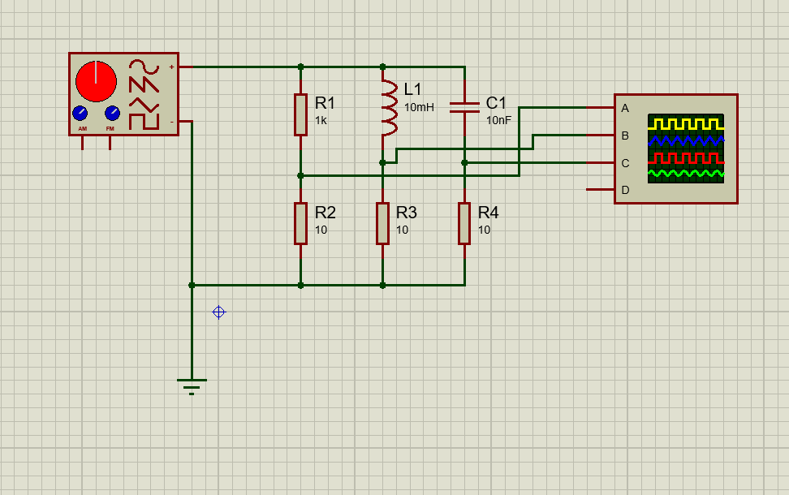

**TABLE:1**

|  |  |  |  |
| --- | --- | --- | --- |
|  | Theoretical | Experimental | %Deviation |
| XC | 1591.55 Ω | 1612.9 Ω | 1.32 % |
| XL | 628.32 Ω | 625 Ω | 0.53 % |
| Z | 1388.46 Ω | 1405.68 Ω | 1.23 % |
| ϴ | -43.93 Deg | -44.65 Deg | 1.61 % |

**TABLE:2**

|  |  |  |  |
| --- | --- | --- | --- |
|  | Theoretical | Experimental | %Deviation |
| IC | 6.28 mA | 6.20mA | 1.27 % |
| IL | 15.9 mA | 16 mA | 0.63 % |
| IR | 10 mA | 10 mA | 0 % |
| IS | 32.18 mA | 32.2 mA | 0.06 % |

**For IR, IC and IL:**

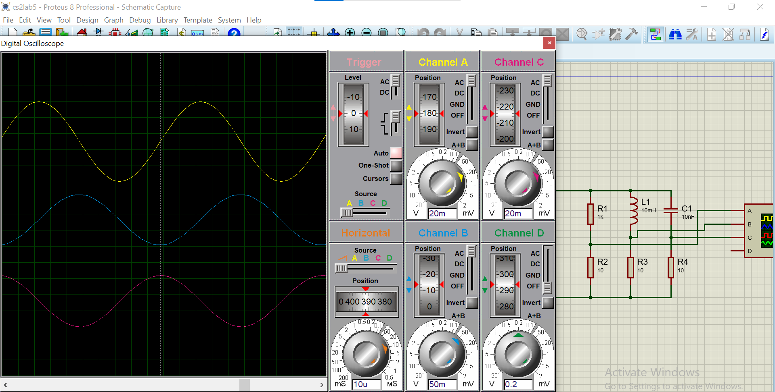

**CONCLUSION:**

We can conclude the following results from this experiment:

* Current is divided in three branches in RLC Parallel circuit while voltage remains constant.
* Kirchhoff’s Current Law (KCL) can also be extended for AC Circuits.
* We cannot measure current directly by oscilloscope. Alternatively, we use sense resistor to measure voltage drop across each element and then use Ohm’s Law for measuring current.